Introduction
A structure emerges from the virtual realm of Creo Parametric, meticulously fashioned through the orchestration of CADCAM software. Its inception can be traced to the harmonious interplay of lines, arcs, and surfaces, with each stroke purposefully woven into a digital tapestry of engineered precision. With pixelated accuracy, each component takes form within the software's crucible, shaped by strategically placed points and curves. Bound by dimensional parameters, these elements are intricately specified in terms of size, location, and relationships, ensuring their seamless integration, reminiscent of pieces in a grand puzzle The assignment of specific materials imparts distinctive properties – the robust strength of steel, the pliable flexibility, the unwavering rigidity – each contributing to the symphony of forces the system is poised to withstand.
1. Design and Assembly:
- Harnessing the formidable capabilities of Creo Parametric software, our system was intricately formed through an extensive process of 3D modeling and assembly.
- Each individual part underwent a meticulous design phase within Creo, ensuring not only a high level of precision but also strict adherence to the specified design criteria. Every component was thoughtfully fashioned, considering its unique role within the broader system.
- The assembly process mirrored this meticulous approach, faithfully reproducing the intended relationships and interactions between components. Every joint, connection, and interface underwent scrutiny to ensure that the assembled system seamlessly conformed to the meticulously crafted virtual model. This unwavering commitment to precision in both design and assembly forms the bedrock of the system's overall integrity and performance.

2. Material Selection:
- The deliberate choice of steel as the primary material for the system emphasizes its well-established attributes of outstanding strength, enduring durability, and remarkable versatility across a broad range of engineering applications. The decision to utilize steel is based on a nuanced assessment of its ability to endure significant loads, resist deformation over time, and seamlessly adapt to diverse operational requirements within the multifaceted field of engineering. This thoughtful evaluation and preference for steel underscore its commendable qualities, positioning it as the optimal foundation to ensure the robust and enduring performance of the system across a myriad of demanding scenarios.

3. Simulation and Analysis:
- Through a thorough simulation process, the system underwent rigorous testing in real-world conditions, with forces and constraints meticulously applied to replicate anticipated loads and restrictions.
- To enhance the accuracy of simulation results, a multi-pass analysis employing a polynomial order of 6 was implemented. This sophisticated analytical approach ensured a nuanced and detailed understanding of the system's behavior under various scenarios, contributing to a more refined simulation outcome.
- Acknowledging the inherent variability in material properties and manufacturing processes, an 8% error tolerance was integrated into the simulation framework. This intentional inclusion allowed for a realistic assessment, accommodating potential fluctuations and ensuring that the simulated results remained robust and applicable across a spectrum of real-world conditions.

4. Output and Reporting:
- The simulation process generated a detailed HTML report, offering a comprehensive understanding of critical aspects related to the system's behavior.
- This exhaustive report delved into key insights, elucidating various aspects such as stress distribution, strain patterns, displacements, and the identification of potential weak points or areas prone to failure. By thoroughly examining these parameters, the report not only showcased the overall performance under simulated conditions but also highlighted specific areas where the system might face challenges or vulnerabilities. This level of detail was crucial in refining the design and strengthening the system against potential weak points, contributing to an enhanced understanding of its structural integrity and performance capabilities.

5. Inferences:
- Material Suitability Analysis: The simulation outcomes will illuminate whether steel aligns optimally with the system's intended function, offering insights into its compatibility, strength, and resilience under simulated conditions.
- Design Optimization Assessment: Conclusions from the analysis may identify specific areas where design modifications could enhance overall performance and prolong the system's lifespan. This involves a nuanced evaluation of structural elements and configurations to pinpoint opportunities for refinement.
- Safety and Reliability Evaluation: The simulation results play a pivotal role in ensuring the overall safety, reliability, and capacity of the system to withstand projected loads and stresses. By scrutinizing stress distribution, strain patterns, and potential weak points, the analysis contributes to fortifying the system against unforeseen challenges and enhancing its ability to meet rigorous safety and reliability standards.

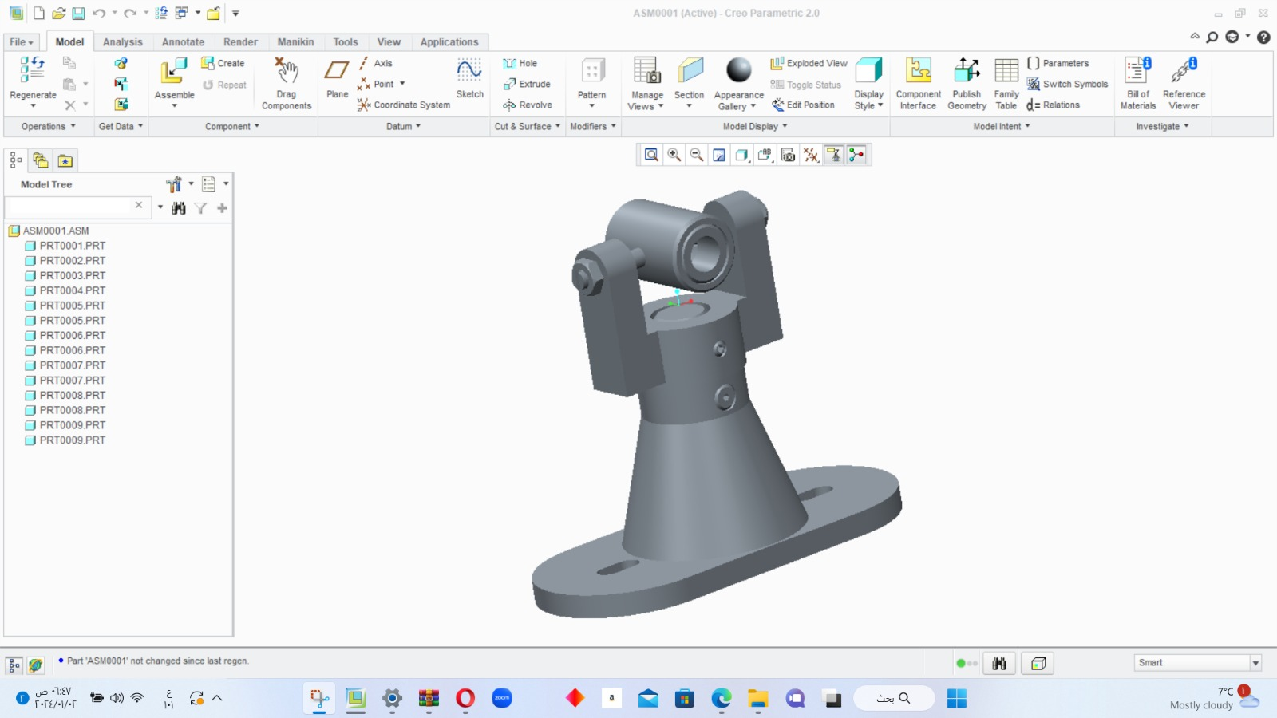
Figure 1: The assembly of all components is now complete.

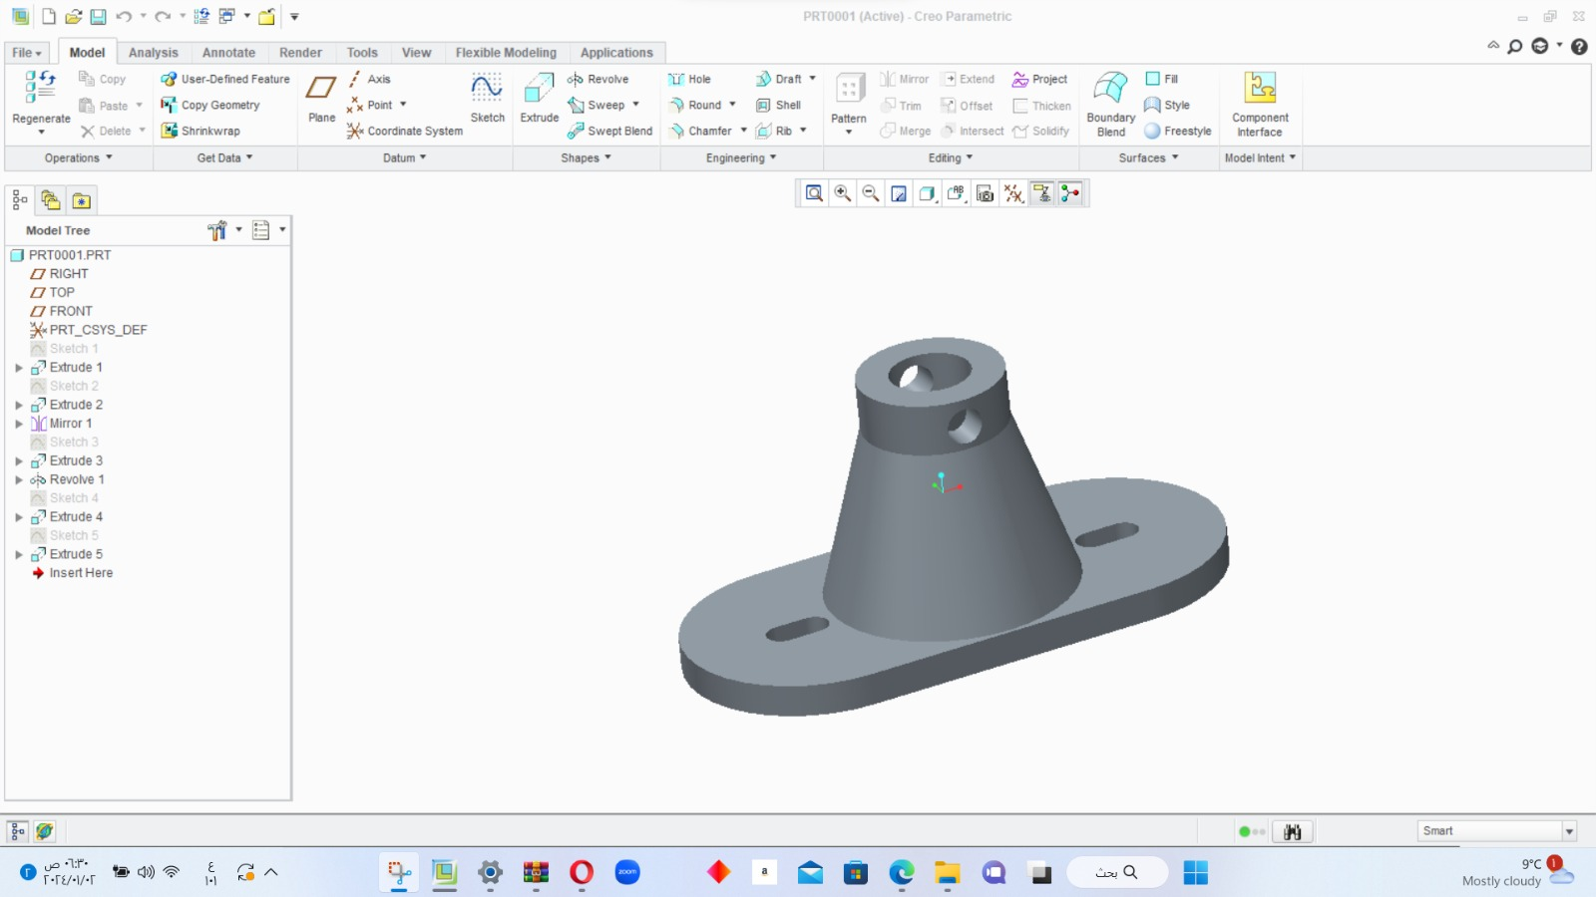
Figure 2 : part 1

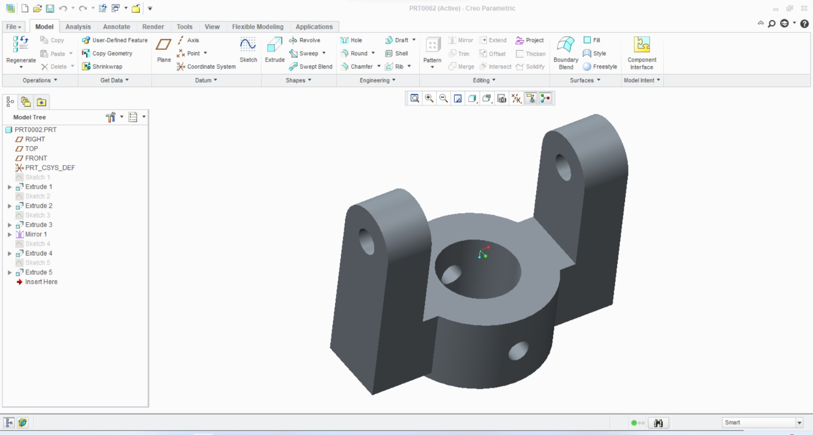

Figure 3: part2
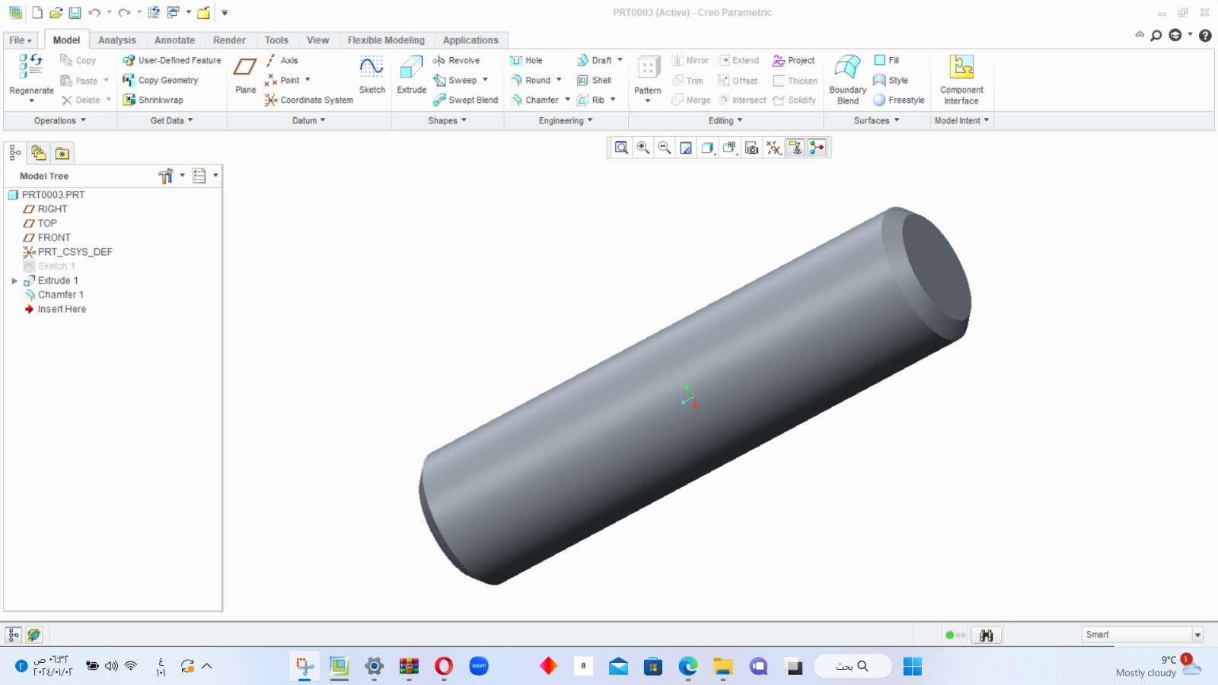
Figure 4: part 3
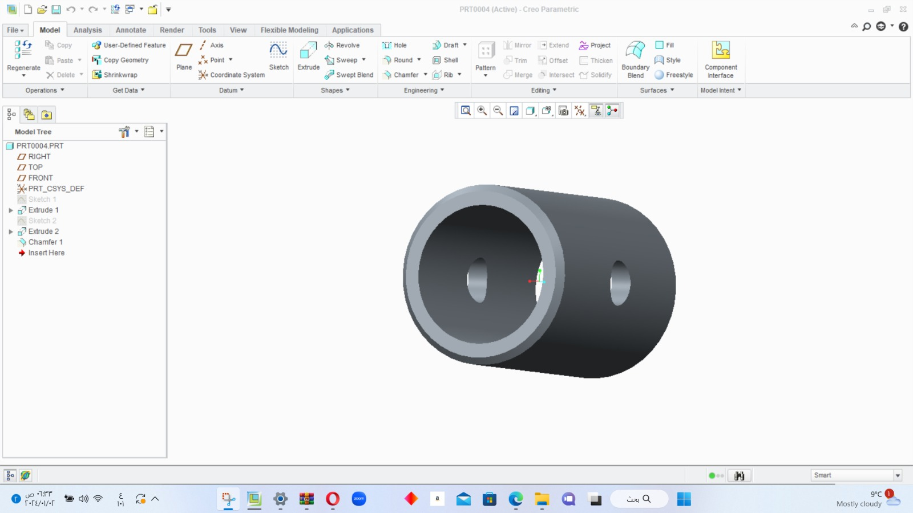

Figure 5: part 4
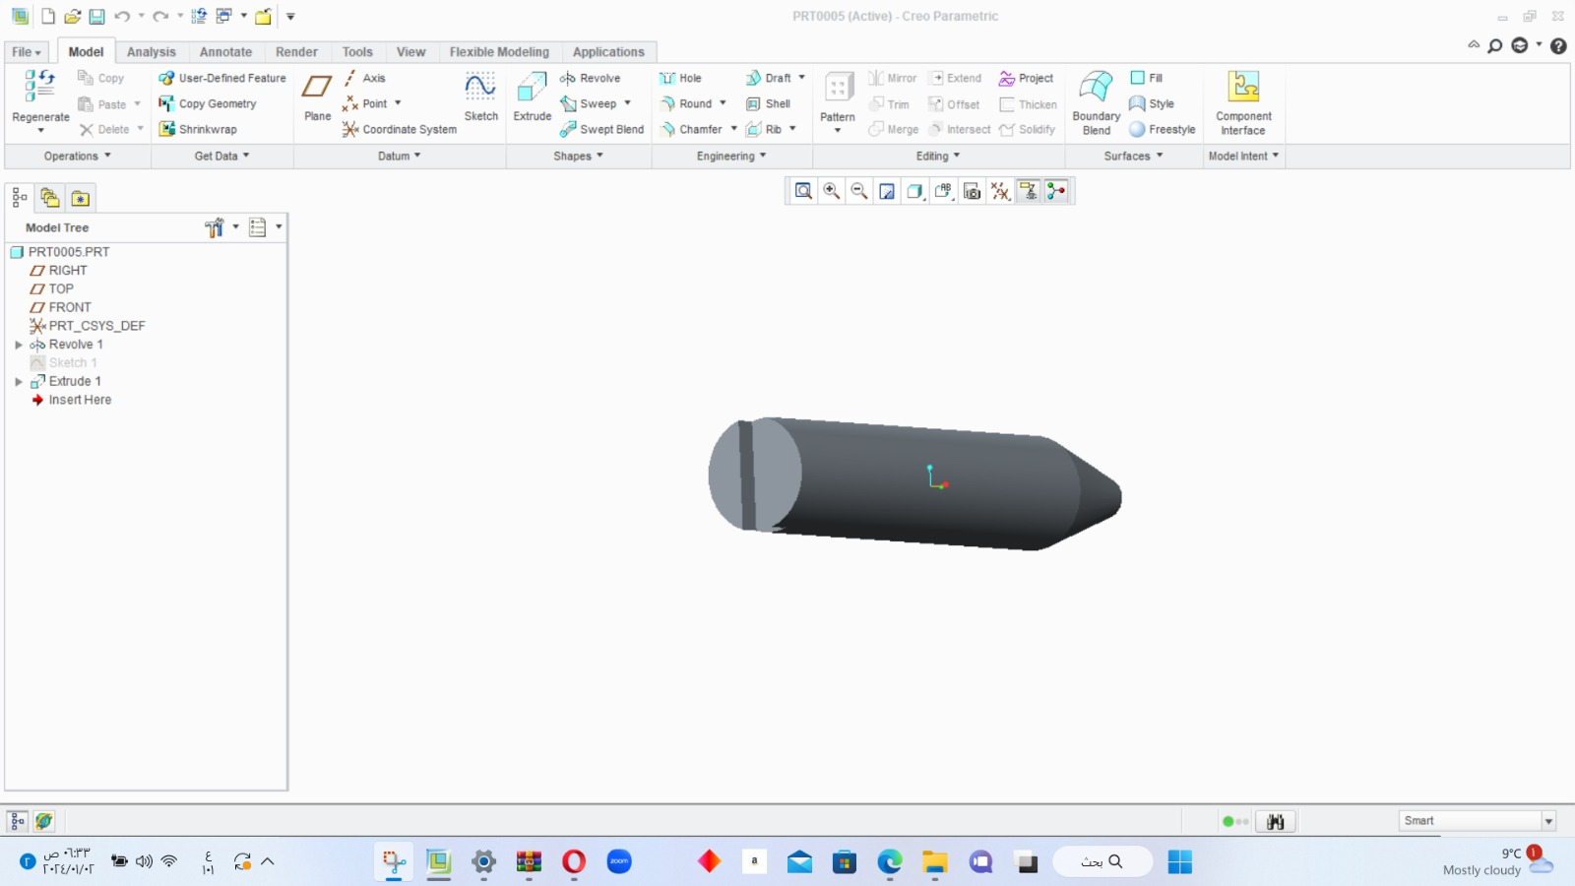
Figure 6: part 5

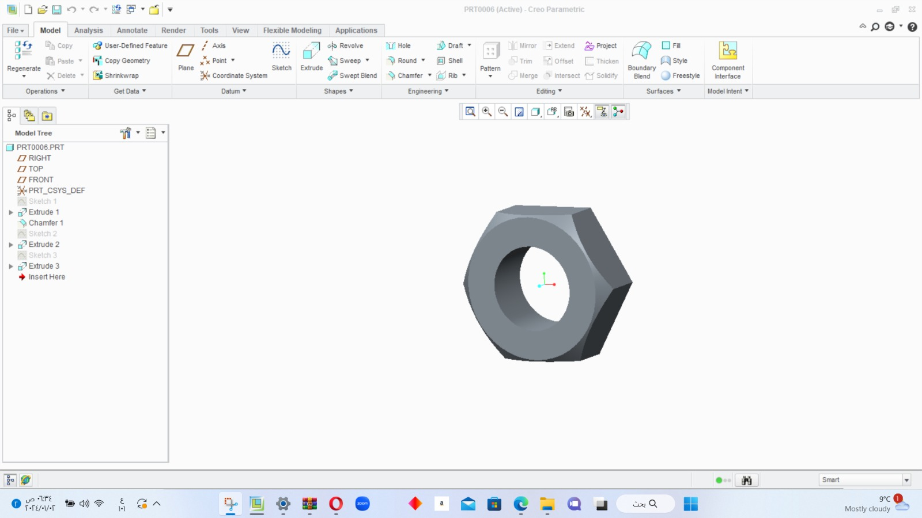Figure 7: part 6

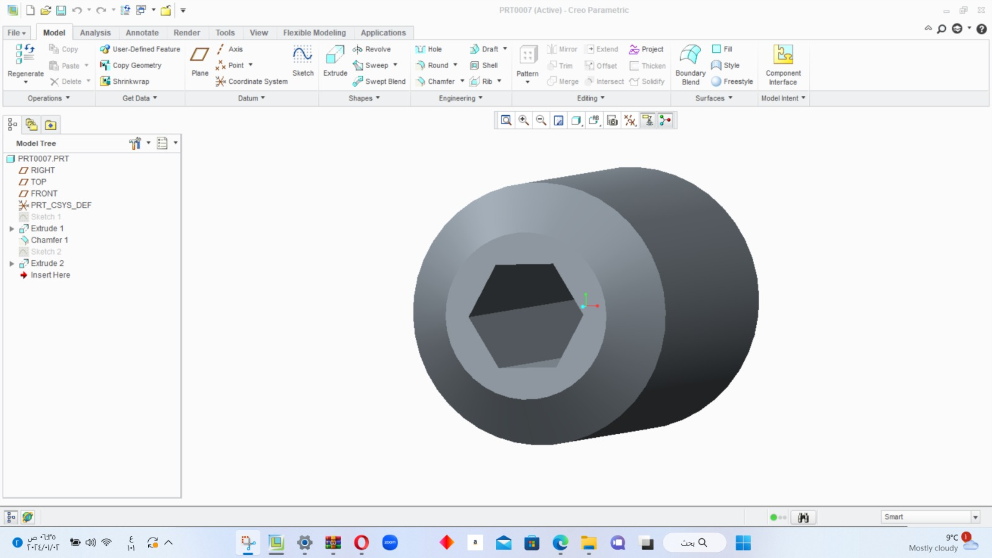

Figure 8 ; part 7
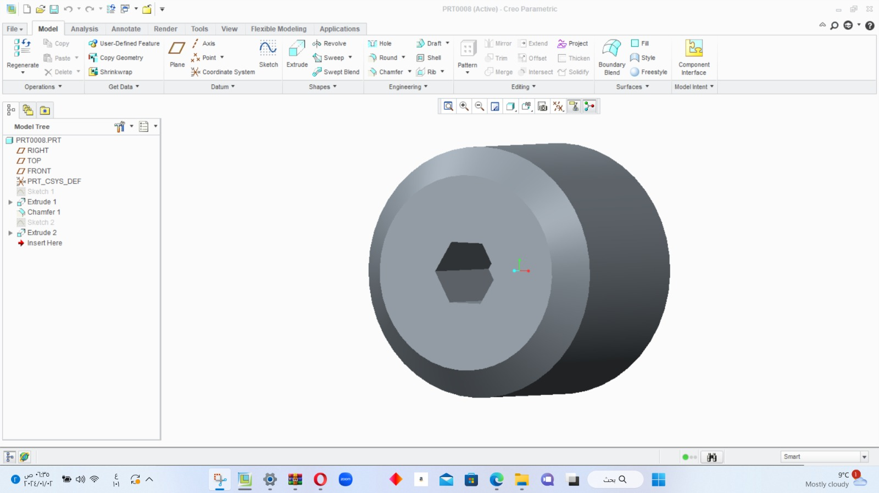

Figure 9 : part 8
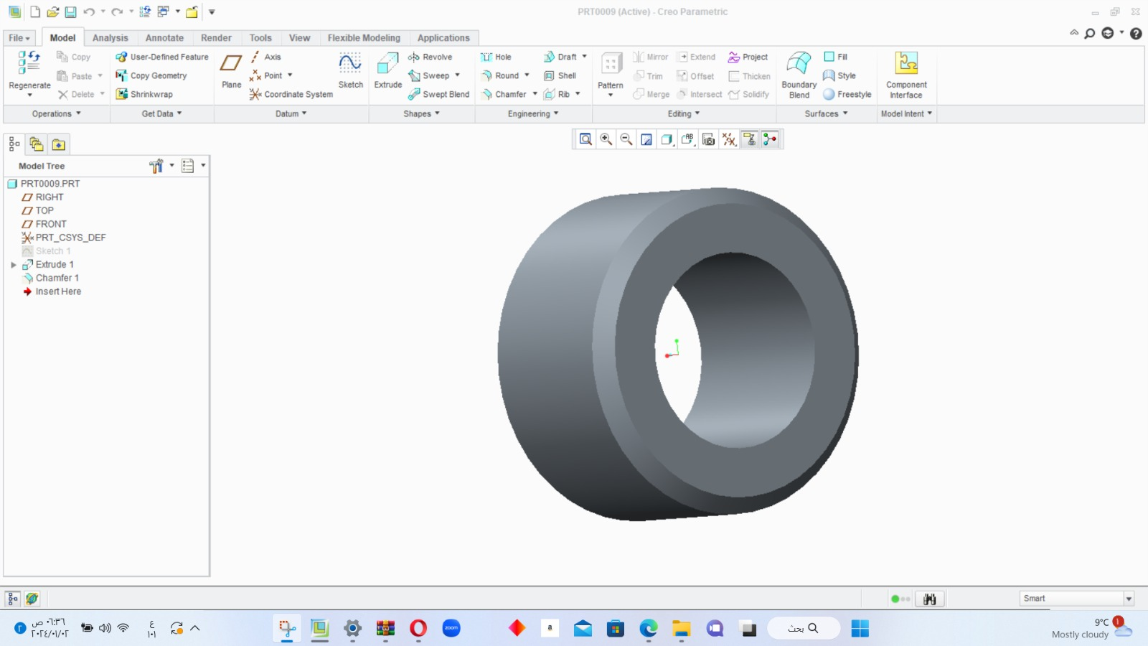
Figure 10 : part 9

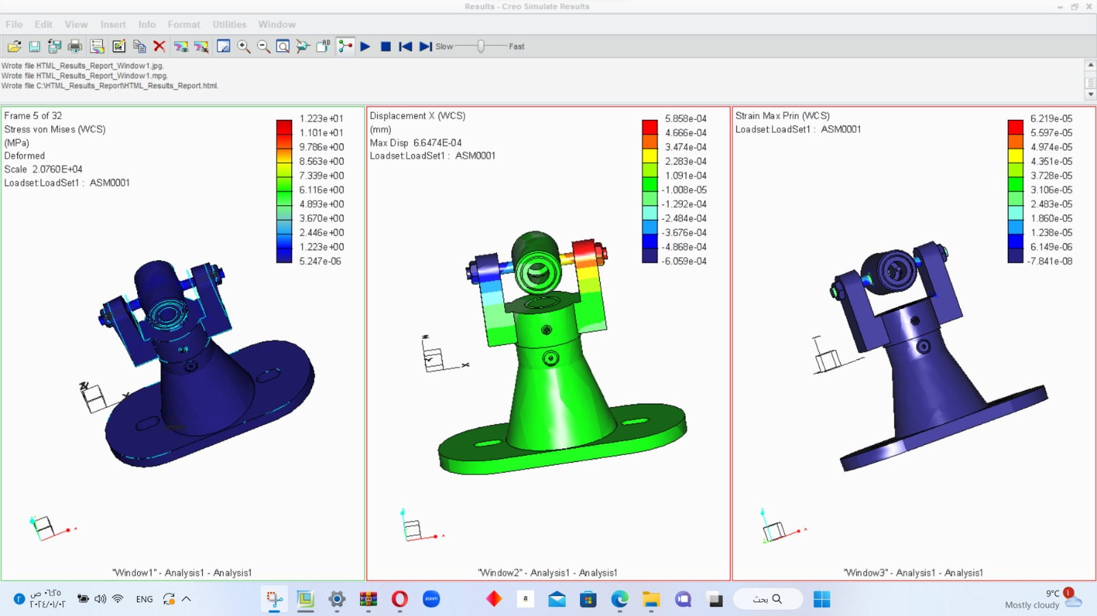
Figure 10 : After applying load variations to the design and stabilizing the system for load analysis, the simulation results illustrate the impact on the von Mises stress, displacement, and force vectors within the design.

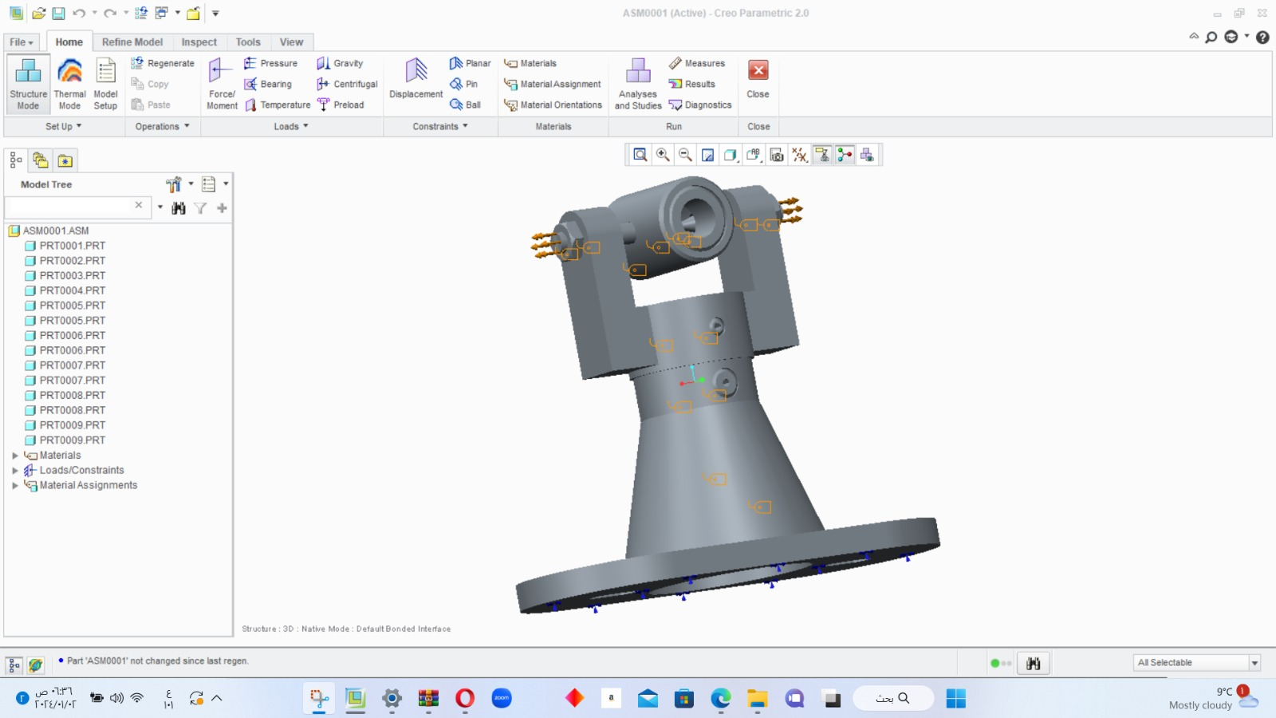
Figure 11
Conclusion:
Leveraging the capabilities of CADCAM software, we have intricately conceived and fine-tuned a system, effectively mitigating risks, reducing expenses, and expediting the development of robust engineering solutions. The digitally crafted representation of our design, executed with meticulous precision, tells a meaningful tale through the judicious selection of materials. At the heart of this narrative is steel, playing a pivotal role and complemented by an array of specialized materials for heightened adaptability. This intricate design serves as the foundational pillar for a seamless transition from the virtual blueprint to a tangible reality. Empowered by this knowledge, we now embark on the conclusive phase.
- translating our digital creation into a vibrant reality on the physical stage.

